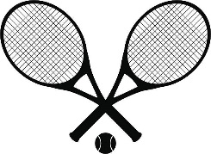
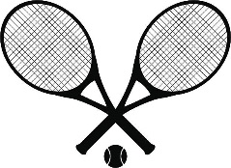
2022 Future Stars
Junior Tennis Camp
Harbor Square Athletic Club
This camp is geared toward beginners and younger players. (approximately 6-13 years old)
Competitive Drills
Strategy: Singles and doubles strategies. Including positioning, high percentage tennis, different styles of play and how to defend against them.
Technique and stroke production: Hand eye coordination, grips. All strokes are covered. Serve, volley, forehand, backhand, overheads.
Match Play: Singles and doubles. Learn Tiebreakers and regular set scoring.
Workouts: Cardio, balance and agility, footwork drills.

SESSION 1: JUNE 27-30 5:00-6:30:00 PM
SESSION 2: JULY 11-14 5:00-6:30 PM
SESSION 3: JULY 18-21 5:00-6:30 PM
SESSION 4: JULY 25-28 5:00-6:30 PM
SESSION 5: AUGUST 1-4 5:00-6:30 PM
SESSION 6: AUGUST 8-11 5:00-6:30 PM
SESSION 7: AUGUST 15-18 5:00-6:30 PM
SESSION 8: AUGUST 22-25 5:00-6:30 PM
SESSION 9: AUGUST 29-SEPT 1 5:00-6:30 PM

Cost: 4 day session: $100
Daily Drop in: $28
Email: perrontennis@gmail.com or text (360) 480-5414
Club Phone: (425) 778-3546

